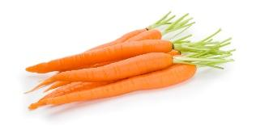
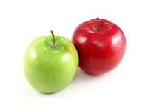
Snack Instructions and Suggestions:
The parents of each child will provide snacks for the class according to the schedule provided each month. You are asked to provide enough snacks to share with all the children (12 students-3 year old class, 16 students- 4 year old class) in the class plus 2-3 staff members. We are required by the state to include foods from at least two of the following food groups. The preschool will provide water with the snack. No drinks needed. Because we are completely private we are allowed to have homemade items!
A few healthy snack suggestions:
*Pick 2 items from different food groups*
- Grain (1/2 slice bread or 1/3 cup cereal per child)
- Muffins
- Crackers – Ritz, graham crackers, animal crackers, Teddy Grahams, Vanilla wafers, etc.
- Cereal – boxes of dry cereal or cereal mixes
- Bagels
- Pretzels
- Granola bars or cereal bars
- Popcorn
- Trail mix
- Rice Krispie bars

- Fruit/Vegetable (at least ½ cup per child)
- Fresh fruit – washed, peeled, and sliced ready to serve
- Canned fruit – applesauce, fruit cocktail, peaches, pears, etc.
- Fruit cups
- Raisins in individual sealed packages
- Carrots

- Dairy (1/2 cup per child)
- Pudding cups
- Cheese – string cheese packages, sliced cheese packages
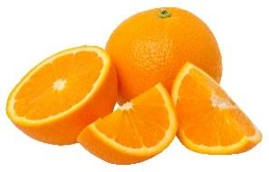
- Gogurt

- Protein (1/2 oz per child)
- Packages of turkey, ham, sausage or cold cuts
- Jar of peanut butter with a package of crackers

Example snack options: crackers & cheese sticks, applesauce & pretzels, fresh fruit & Go-gurt

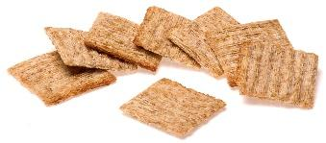
(A refrigerator is available for storage of perishable items.)

